alien needs

# **important information students should find**

Students should identify *at least* the following needs for each species.  If you have students compile a list of needs as a class, you may want to prompt them if they are missing any of the following. If students generate additional needs, make sure that they are accurate and that they actually represent a need rather than simply a characteristic of the species.

## **Contents**

* 1 The Akona
* 2 The Eolani
* 3 The Jakala-Tay
* 4 The Kaylid
* 5 The Sylcari
* 6 The Wroft

## **The Akona**

|  |  |
| --- | --- |
| **Akona** | **Location of Hint in Alien Database** |
| ·        10K to 100K | Habitat, Inhabited Worlds: Akonid |
| ·        Carbon, nitrogen | Food |
| ·        Little atmosphere | Dwellings |
| ·        Hard surface | Dwellings |
| ·        No seismic activity | Body |
| ·        Mountains | Inhabited Worlds: Akonid |
| ·        Gravity is one-eighth Earth’s | Inhabited Worlds: Akonid |

Back to Top

## **The Eolani**

|  |  |
| --- | --- |
| **Eolani** | **Location of Hint in Alien Database** |
| ·        Oxygen in atmosphere | Habitat |
| ·        Water | Habitat |
| ·        Prefer 270-300K, can raise temperature 100K | Habitat, Technology |
| ·        No seismic activity | Dwellings |
| ·        Gravity about one-quarter of Earth’s | Inhabited Worlds: Eola |
| ·        Magnetic field | Inhabited Worlds: Eola |

Back to Top

## **The Jakala-Tay**

|  |  |
| --- | --- |
| **Jakala-Tay** | **Location of Hint in Alien Database** |
| ·        Sulfur in atmosphere | Habitat |
| ·        Nitrogen | Food |
| ·        No hydrogen | Habitat |
| ·        Metals | Dwellings |
| ·        Earthquakes okay | Dwellings |
| ·        Temperature 200-500K | Inhabited Worlds: Tay |
| ·        Gravity is one-third of Earth | Inhabited Worlds: Tay |

[Back to Top](http://www.edb.utexas.edu/minliu/alienrescue/index.php?title=Alien_Needs&printable=yes#top)

## **The Kaylid**

|  |  |
| --- | --- |
| **Kaylid** | **Location of Hint in Alien Database** |
| ·        100K - 650K (sleep below 250K) | Habitat, Inhabited Worlds: Kayl |
| ·        Oxygen, sodium | Technology |
| ·        Caves | Habitat, Inhabited Worlds: Kayl |
| ·        Iron and nickel | Inhabited Worlds: Kayl |
| ·        No strong earthquakes | Inhabited Worlds: Kayl |
| ·        Gravity is one-half Earth’s | Inhabited Worlds: Kayl |

Back to Top

## **The Sylcari**

|  |  |
| --- | --- |
| **Sylcari** | **Location of Hint in Alien Database** |
| ·        Water, ocean | Body, Habitat,  Inhabited Worlds: Sylcar |
| ·        Calcium (for melk) | Dwellings |
| ·        Gravity about one-fifth of Earth’s | Inhabited Worlds: Sylcar |
| ·        Needs atmosphere | Food |

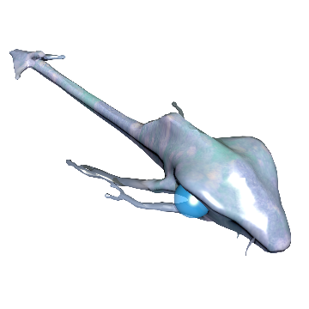

Back to Top

## **The Wroft**

|  |  |
| --- | --- |
| **Wroft** | **Location of Hint in Alien Database** |
| ·        Thick atmosphere | Habitat |
| ·        Surface (maybe not necessary) |  |
| ·        No lightning | Habitat |
| ·        Carbon in atmosphere | Food |
| ·        Sulfur (not necessary) | Food |
| ·        No magnetic field | Body |
| ·        Gravity is six-tenths of Earth’s, but not important | Habitat, Inhabited Worlds: Wroft-Gar |
| ·        400K near surface, 100K high in atmosphere | Habitat, Inhabited Worlds: Wroft-Gar |

Back to Top